**Using pseudo random numbers to estimate the area of two overlapping ellipses.**

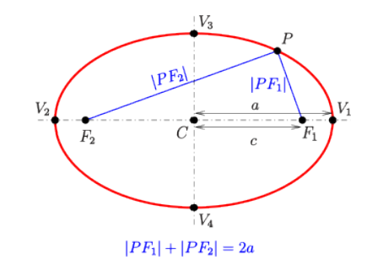

Create a Point class that takes the x and y coordinates of the point: p1 = Point(2,3) p2 = Point(4,3)

Create an Ellipse class that takes two points and the width of the long axis: e1 = Ellipse(p1,p2,4)

Write a function that takes two ellipses and returns the area of the overlap: overlap = computeOverlapOfEllipses(e1,e2) This function should leverage the built pseudo random number generator.

Test your code on the case where two circles are at the origin.

Test your code on two more complicated examples you came up with.

For each test, display the output in the form:

"Ellipse(Point(x11,y11),Point(x12,y12),w1) has area a1 Ellipse(Point(x21,y21),Point(x22,y22),w2) has area a2

YYYY out of ZZZZZ generated points are in both ellipses.

The overlap of the two has area a3."

Where a1, a2 are analytical results, and YYYY, ZZZZ and a3 are the empirical results from the simulation